AutoEmail Full Installation Tests
Tester: Tony Tasker
Date: 19th December 2016
Time: 17:00
PC/Server: TonyTasker-PC
Database: CABS_TEST (Copy of SHU DB)
Works Summary: N/A
Works Order: N/A
Task: N/A
Notes: These tests were performed using Microsoft SQL Server Management Studio. Output to the Results and Messages Output Windows are used to determine the success of the tests. Also the receipt of emails.

Testing change emails to MBR Contact as opposed to Client, only sending emails with a Classification of Helpdesk and a change of table format. More details below.

Pre-Test Setup
No | Task | Tester | Pass | Notes
1 | In X CABS Config, Section CABS_AUTO_EMAIL_FUNCS if WIPWindow is set then  WIPWindow=0  Set DebugFlag=1  In section CABS_AUTO_EMAIL_FUNCS_Trigger  Set DebugFlag=1 | TT
2 |  | TT

Post-Test Setup
No | Task | Tester | Pass | Notes
1 | Reverse any Config Changes in X CABS Config | TT

Tests

Cancelled Booking Email – AEFCXL
No | Test | Tester | Pass | Notes
1 | In CABS locate a function to test with:  SELECT * FROM FUNC_FIL WHERE F_STARTDATETIME > GETDATE()  Using F117285  Get the MBR No  SELECT F_MBR_NO FROM FUNC_FIL WHERE F_REF = 'F117285'  Using M015242  Ensure correct classification  SELECT * FROM AC10 WHERE AC_OWNER = 'M015242'  Should return a record  Ensure following settings are set in System Defaults, Section AEFCXL:  ClassConstraint1 = 1  SendToBooker=0  SendToContact=1  SendToDepartment=1  And  Section DeptEmailAddresses  CATER=tony.tasker@positivelyonline.co.uk | TT |  | Testing that the email is sent to both the email defined in the CATER Department Email address and the MBR Contact Email address.  Have not tested the Helpdesk classification as this has been previously tested
2 | Change the status of the Function to Provisional  UPDATE FUNC_FIL SET F_STATUS = 'CANCEL' WHERE F_REF = 'F117285'  Check status of AutoEmail Queue  SELECT * FROM vw_AEFLINK WHERE AEFL_FREF = 'F117285' | TT |  | For Email Template AEFCXL:  AEFL_CanSend should be 1,  AEFL_Sent should be 0,  SessionSendable should be 1,  Sendable should be 1,  MatchCriteria should be 1
3 | Process the AutoEmail  EXEC CABS_AUTO_EMAIL_FUNCS_SESS_CHECK | TT |  | Email delivered as per Figure 1

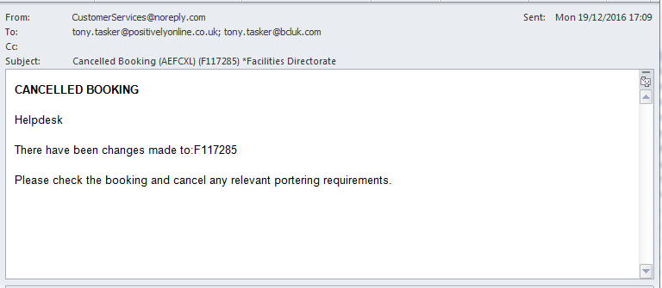
Figure 1 – Cancelled Booking AutoEMail – Sent to MBR Contact and Department

Feedback Form from Customer Email – AEFFFC
No | Test | Tester | Pass | Notes
1 | In CABS locate a function to test with:  SELECT * FROM FUNC_FIL WHERE F_STARTDATETIME < GETDATE()  Using F119342  Get the MBR No  SELECT F_MBR_NO FROM FUNC_FIL WHERE F_REF = 'F119342'  Using M015634  Ensure correct classification  SELECT * FROM AC10 WHERE AC_OWNER = 'M015634'  Should return a record if not add a record  Ensure following settings are set in System Defaults, Section AEFFFC:  ClassConstraint1 = 1  SendToBooker=0  SendToClient=0  SendToContact=1 | TT |  | Testing that the email is sent to the MBR Contact Email address.
2 | Update the status of the Function to CONFRM  UPDATE FUNC_FIL SET F_STATUS = 'CONFRM' WHERE F_REF = 'F119342'  Check status of AutoEmail Queue  SELECT * FROM vw_AEFLINK WHERE AEFL_FREF = 'F119342' | TT |  | For Email Template AEFFFC:  AEFL_CanSend should be 1,  AEFL_Sent should be 0,  SessionSendable should be 1,  Sendable should be 1,  MatchCriteria should be 1
3 | Process the AutoEmail  EXEC CABS_AUTO_EMAIL_FUNCS_SESS_CHECK | TT |  | Email delivered as per Figure 2

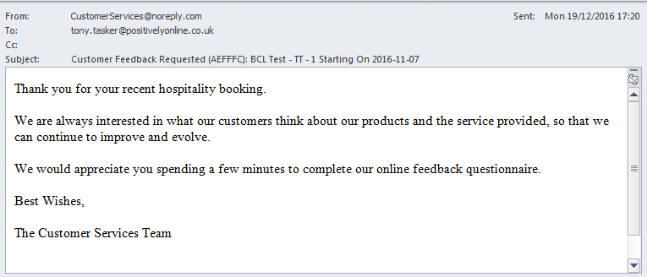
Figure 2 – Feedback From Customer Request AutoEMail

Feedback Form from Customer Email – AEFFFC – No Classification
No | Test | Tester | Pass | Notes
1 | Change the classification. Run script  UPDATE AC10 SET AC_CODE = 'NOHELP'WHERE AC_OWNER = 'M015634' | TT |  | Testing that the email is not sent when the Classification is not HelpDesk
2 | Update the status of the Function to CONFRM  UPDATE FUNC_FIL SET F_STATUS = 'CONFRM' WHERE F_REF = 'F119342' | TT
3 | Process the AutoEmail  EXEC CABS_AUTO_EMAIL_FUNCS_SESS_CHECK | TT |  | Confirm No Email Delivered
4 | Change the classification back. Run script  UPDATE AC10 SET AC_CODE = 'HELP' WHERE AC_OWNER = 'M015634' | TT

Provisional Booking Email – AEFPBK
No | Test | Tester | Pass | Notes
1 | In CABS locate a function to test with:  SELECT * FROM FUNC_FIL WHERE F_STARTDATETIME > GETDATE()  Using F117285  Get the MBR No  SELECT F_MBR_NO FROM FUNC_FIL WHERE F_REF = 'F117285'  Using M015242  Ensure correct classification  SELECT * FROM AC10 WHERE AC_OWNER = 'M015242'  Should return a record  Ensure following settings are set in System Defaults, Section AEFPBK:  ClassConstraint1 = 1  SendToBooker=0  SendToContact=1  SendToDepartment=0 | TT |  | Testing that the email is sent to the MBR Contact Email address.
2 | Change the status of the Function to Provisional  UPDATE FUNC_FIL SET F_STATUS = 'PROVNL'  WHERE F_REF = 'F117285'  Check status of AutoEmail Queue  SELECT * FROM vw_AEFLINK WHERE AEFL_FREF = 'F117285' | TT |  | For Email Template AEFPBK:  AEFL_CanSend should be 1,  AEFL_Sent should be 0,  SessionSendable should be 1,  Sendable should be 1,  MatchCriteria should be 1
3 | Process the AutoEmail  EXEC CABS_AUTO_EMAIL_FUNCS_SESS_CHECK | TT |  | Email delivered as per Figure 3

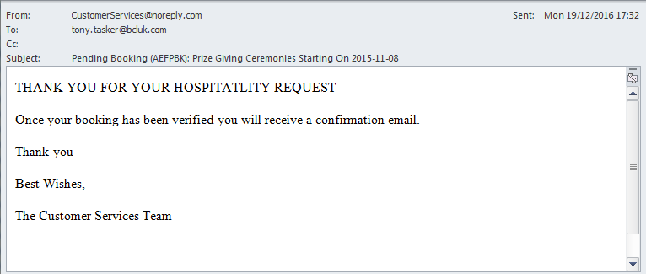
Figure 3 - Provisional Booking AutoEMail – Sent to MBR Contact

Provisional Booking Email – AEFPBK – No Classification
No | Test | Tester | Pass | Notes
1 | Change the classification. Run script  UPDATE AC10 SET AC_CODE = 'NOHELP'WHERE AC_OWNER = 'M015242' | TT |  | Testing that the email is not sent when the Classification is not HelpDesk
2 | Update the status of the Function to CONFRM  UPDATE FUNC_FIL SET F_STATUS = 'PROVNL'  WHERE F_REF = 'F117285' | TT
3 | Process the AutoEmail  EXEC CABS_AUTO_EMAIL_FUNCS_SESS_CHECK | TT |  | Confirm No Email Delivered
4 | Change the classification back. Run script  UPDATE AC10 SET AC_CODE = 'HELP' WHERE AC_OWNER = 'M015242' | TT

Booking Confirmation Email – AEFCON
No | Test | Tester | Pass | Notes
1 | In CABS locate a function to test with:  SELECT * FROM FUNC_FIL WHERE F_STARTDATETIME > GETDATE()  Using F117285  Get the MBR No  SELECT F_MBR_NO FROM FUNC_FIL WHERE F_REF = 'F117285'  Using M015242  Ensure correct classification  SELECT * FROM AC10 WHERE AC_OWNER = 'M015242'  Should return a record  Ensure following settings are set in System Defaults, Section AEFCON:  ClassConstraint1 = 1  SendToBooker=0  SendToContact=1  SendToDepartment=0  If no extras on function then some will need to be added including costs. | TT |  | Testing that the email is sent to the MBR Contact Email address.  Also testing new Total Price column on the Extras Table
2 | Change the status of the Function to Provisional  UPDATE FUNC_FIL SET F_STATUS = 'CONFRM'  WHERE F_REF = 'F117285'  Check status of AutoEmail Queue  SELECT * FROM vw_AEFLINK WHERE AEFL_FREF = 'F117285' | TT |  | For Email Template AEFCON:  AEFL_CanSend should be 1,  AEFL_Sent should be 0,  SessionSendable should be 1,  Sendable should be 1,  MatchCriteria should be 1
3 | Process the AutoEmail  EXEC CABS_AUTO_EMAIL_FUNCS_SESS_CHECK | TT |  | Email delivered as per Figure 4

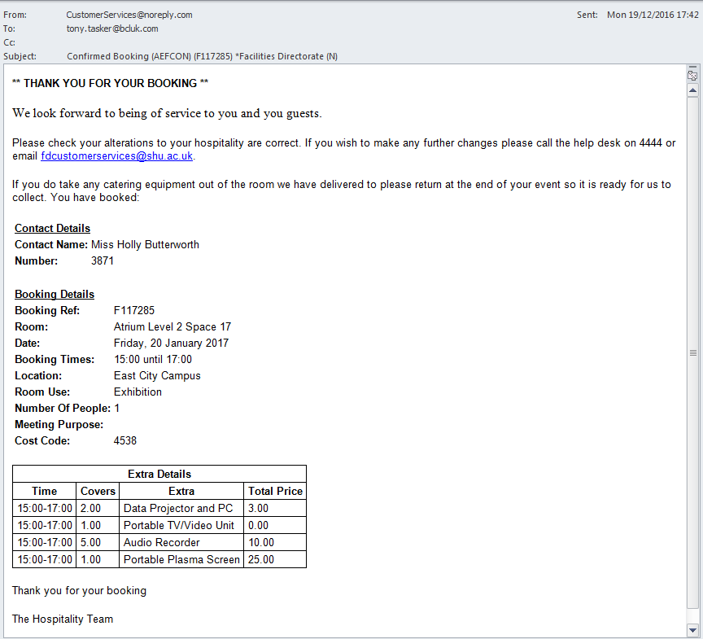
Figure 4 – Booking Confirmation AutoEMail – Sent to MBR Contact with Total Price Column

Booking Email – AEFCON – No Classification
No | Test | Tester | Pass | Notes
1 | Change the classification. Run script  UPDATE AC10 SET AC_CODE = 'NOHELP'WHERE AC_OWNER = 'M015242' | TT |  | Testing that the email is not sent when the Classification is not HelpDesk
2 | Update the status of the Function to CONFRM  UPDATE FUNC_FIL SET F_STATUS = 'CONFRM'  WHERE F_REF = 'F117285' | TT
3 | Process the AutoEmail  EXEC CABS_AUTO_EMAIL_FUNCS_SESS_CHECK | TT |  | Confirm No Email Delivered
4 | Change the classification back. Run script  UPDATE AC10 SET AC_CODE = 'HELP' WHERE AC_OWNER = 'M015242' | TT

Delivery to Outer Building – AEFDOB
No | Test | Tester | Pass | Notes
1 | Using F119341  Get the MBR No  SELECT F_MBR_NO FROM FUNC_FIL WHERE F_REF = 'F119341'  Using M015357  Ensure correct classification  SELECT * FROM AC10 WHERE AC_OWNER = 'M015357'  Should return a record  Ensure following settings are set in System Defaults, Section AEFDOB:  ClassConstraint1 = 1  SendToDepartment=1  And  Section DeptEmailAddresses  PRODMNGR= tony.tasker@positivelyonline.co.uk | TT |  | Testing that the email is sent to the departmental address set in PRODMNGR in section DeptEmailAddresses.
2 | Change the status of the Function to Provisional  UPDATE FUNC_FIL SET F_STATUS = 'CONFRM'  WHERE F_REF = 'F119341'  Check status of AutoEmail Queue  SELECT * FROM vw_AEFLINK WHERE AEFL_FREF = 'F119341' | TT |  | For Email Template AEFDOB:  AEFL_CanSend should be 1,  AEFL_Sent should be 0,  SessionSendable should be 1,  Sendable should be 1,  MatchCriteria should be 1
3 | Process the AutoEmail  EXEC CABS_AUTO_EMAIL_FUNCS_SESS_CHECK | TT |  | Email delivered as per Figure 5

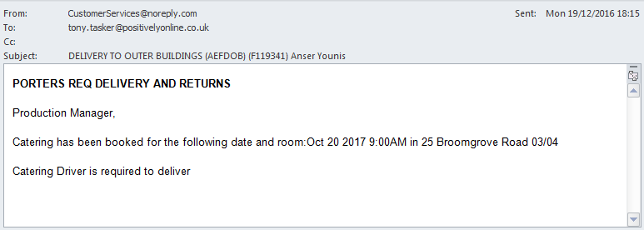
Figure 5 – Delivery To Outer Building AutoEMail – Sent to Department

Delivery to Outer Building – AEFDOB – No Classification
No | Test | Tester | Pass | Notes
1 | Change the classification. Run script  UPDATE AC10 SET AC_CODE = 'NOHELP' WHERE AC_OWNER = 'M015357' | TT |  | Testing that the email is not sent when the Classification is not HelpDesk
2 | Update the status of the Function to CONFRM  UPDATE FUNC_FIL SET F_STATUS = 'CONFRM'  WHERE F_REF = 'F119341' | TT
3 | Process the AutoEmail  EXEC CABS_AUTO_EMAIL_FUNCS_SESS_CHECK | TT |  | Confirm No Email Delivered
4 | Change the classification back. Run script  UPDATE AC10 SET AC_CODE = 'HELP' WHERE AC_OWNER = 'M015357' | TT

